1. What are the basic principles of creating a dashboard?

Answer: Some of the basic principles must be followed when creating one must include.

1. Who the audience is?
2. Decide the flow- write it
3. What value does the dashboard add?
4. What type of dashboard to prepare, Operational, Analytical or strategic
5. Make it interactive
6. Keep in mind: No scrolling, keep required stuff and within a single page
7. All reports need NOT to be on same sheet, you can connect multiple sheets later with 'Hyperlink'
8. Add drill down by using form controls which can navigate to next levels of the metrics
9. Include actional insights - this will help the audience to take actions against your insights
10. Always name the Pivot reports
11. Do Not use redundant reports and charts (giving same information).
12. Keep it Simple
13. What is a dashboard?

Answer: Dashboards are highly effective in validating the effectiveness of the metrics captured over time and bring out the leading trends. A dashboard is generally defined as a real-time tool which has easy to read user interface showing a graphical presentation of data, it is also an effective way to take actionable insights.

A dashboard is an information management tool used to track KPIs, metrics, and key data points that are relevant to your business, department, or a specific process. Dashboards aggregate and visualize data from multiple sources, such as databases, locally hosted files, and web services. It would instantly answer important questions such which regions are performing better and which products should the management focus on. • These dashboards could be static or interactive (where the user can make selections and change views and the data would dynamically update)

1. You have to add a chart to your dashboard & that is linked to a Pivot? How will it refresh?

Answer: To refresh the data source for any pivot table or charts linked with the pivot table, you need to go to the ribbon Pivot Table Analyse> Data Refresh or use the short cut to execute this, Ctl+Alt+F5

1. Your dashboard has a date wise performance, you need to place arrows if the performance for current day is increased, decreased or stable in the same cell. What will you do?

Answer: First add an additional column which has formula to calculate difference from previous to current value. To highlight the data in the forms of arrows we will have to use conditional formatting, Select the range in new column, and then go to the ribbon>Home>ConditionalFormatting>Icon Sets>Directional. This will show data in form of arrows.

1. Can a dashboard contain only tables or only charts?

Answer: yes, it can be combination of both too.

1. What are the elements/objects present in excel which can be used inside a dashboard?

Answer: Table reports,Charts,Slicers,Timelines,Sparklines,images,colors,shapes,hyperlinks and more.

1. What type of chart is this?  
   [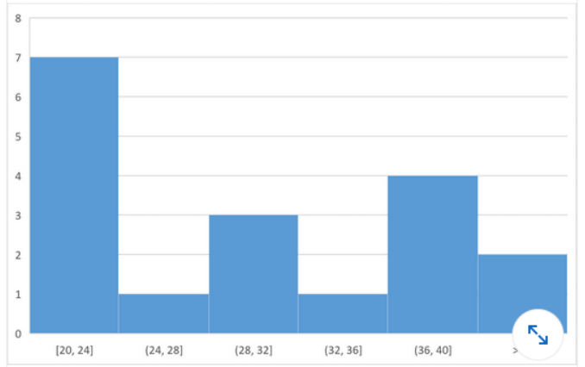](https://user-images.githubusercontent.com/48485675/221608974-f1fa1369-9a52-43d5-a738-5744ede084bc.png)
   1. **histogram**
   2. waterfall
   3. treemap
   4. box and whisker
2. What type of chart is this?  
   [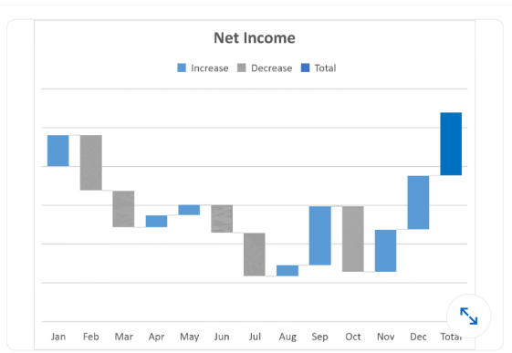](https://user-images.githubusercontent.com/125942986/223951588-6460e0d2-9c18-4232-b087-5741e3212d3c.png)
   1. histogram
   2. **waterfall**
   3. treemap
   4. box and whisker
3. You want to track the progress of the stock market on a daily basis. Which type of chart should you use?
   1. Pie chart
   2. Row chart
   3. **Line chart**
   4. Column chart
4. In MS-Excel data marker on a chart are linked to data points in a worksheet, therefore
   1. You can automatically apply formatting to a data series
   2. You can change the position of a data marker and that automatically changes the data point value in the worksheet
   3. **You can change a data point value and automatically that is drawn in the chart**
   4. Both (b) & (c)
5. In MS-Excel what chart object is horizontal or vertical line that extends across the plot area to make it easier to read and follow the values?
   1. Category axis
   2. Data marker
   3. Both (a) & (b)
   4. **Gridline**
6. In MS Excel, On the Insert tab includes:
   1. **Chart**
   2. Alignment
   3. Style
   4. All of these
7. In MS-Excel you can insert labels for
   1. All the data markers on a chart
   2. A data series
   3. A selected data marker
   4. **All of the above**
8. In MS-Excel chart wizard term data series refers to
   1. A chart legend
   2. A collection of chart data markers
   3. **A set of values you plot in a chart**
   4. None of these
9. You need to add a line chart showing a sales trends over the last 12 months and you have only a little space to work with. How can you convey the required information within a single cell?
   1. Add an image of the chart to a comment.
   2. Add a hyperlink to another worksheet that displays a chart when clicked.
   3. Add an image of the chart to the worksheet.
   4. **Add a sparkline, a graphic that summarizes data visually within a single worksheet cell.**
10. Of the four chart types listed, which works best for summarizing time-based data?
    1. pie chart
    2. **line chart**
    3. XY scatter chart
    4. bar chart
11. An organization chart, which shows the hierarchy within a company or organization, is available as _ that is included with Excel.
    1. a 3D model
    2. **SmartArt**
    3. a Treemap chart
    4. a drawing object
12. Which chart type can display two different data series as a different series type within the same chart?  
    [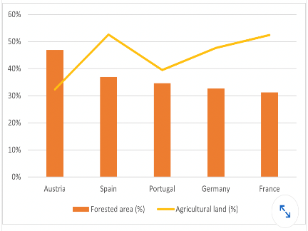](https://camo.githubusercontent.com/aad33973b39dacfbfc3d309a86ae20b932af3ab84b8cf9bea6ced009ec1f9cf9/68747470733a2f2f692e696d6775722e636f6d2f7a3242667149462e706e67)
    1. XY chart
    2. clustered column
    3. bubble chart
    4. **combo chart**
13. After activating a chart, which sequence adds a trendline to the chart?
    1. In the Format group, select Trendline from the Insert Shapes list.
    2. Click outside the plot area and select Add Trendline
    3. Click inside the plot and select Forecast.
    4. **Right-click a data series and select Add Trendline.**
14. . The charts below are based on the data in cells A3:G5. The chart on the right was created by copying the one on the left. Which ribbon button was clicked to change the layout of the chart on the right?  
    [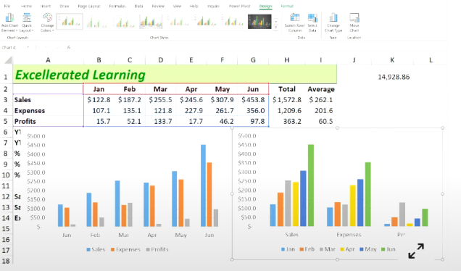](https://github.com/Ebazhanov/linkedin-skill-assessments-quizzes/blob/main/microsoft-excel/images/002.png?raw=true)
    1. Move Chart
    2. **Switch Row/Column**
    3. Quick Layout
    4. Change Chart Type